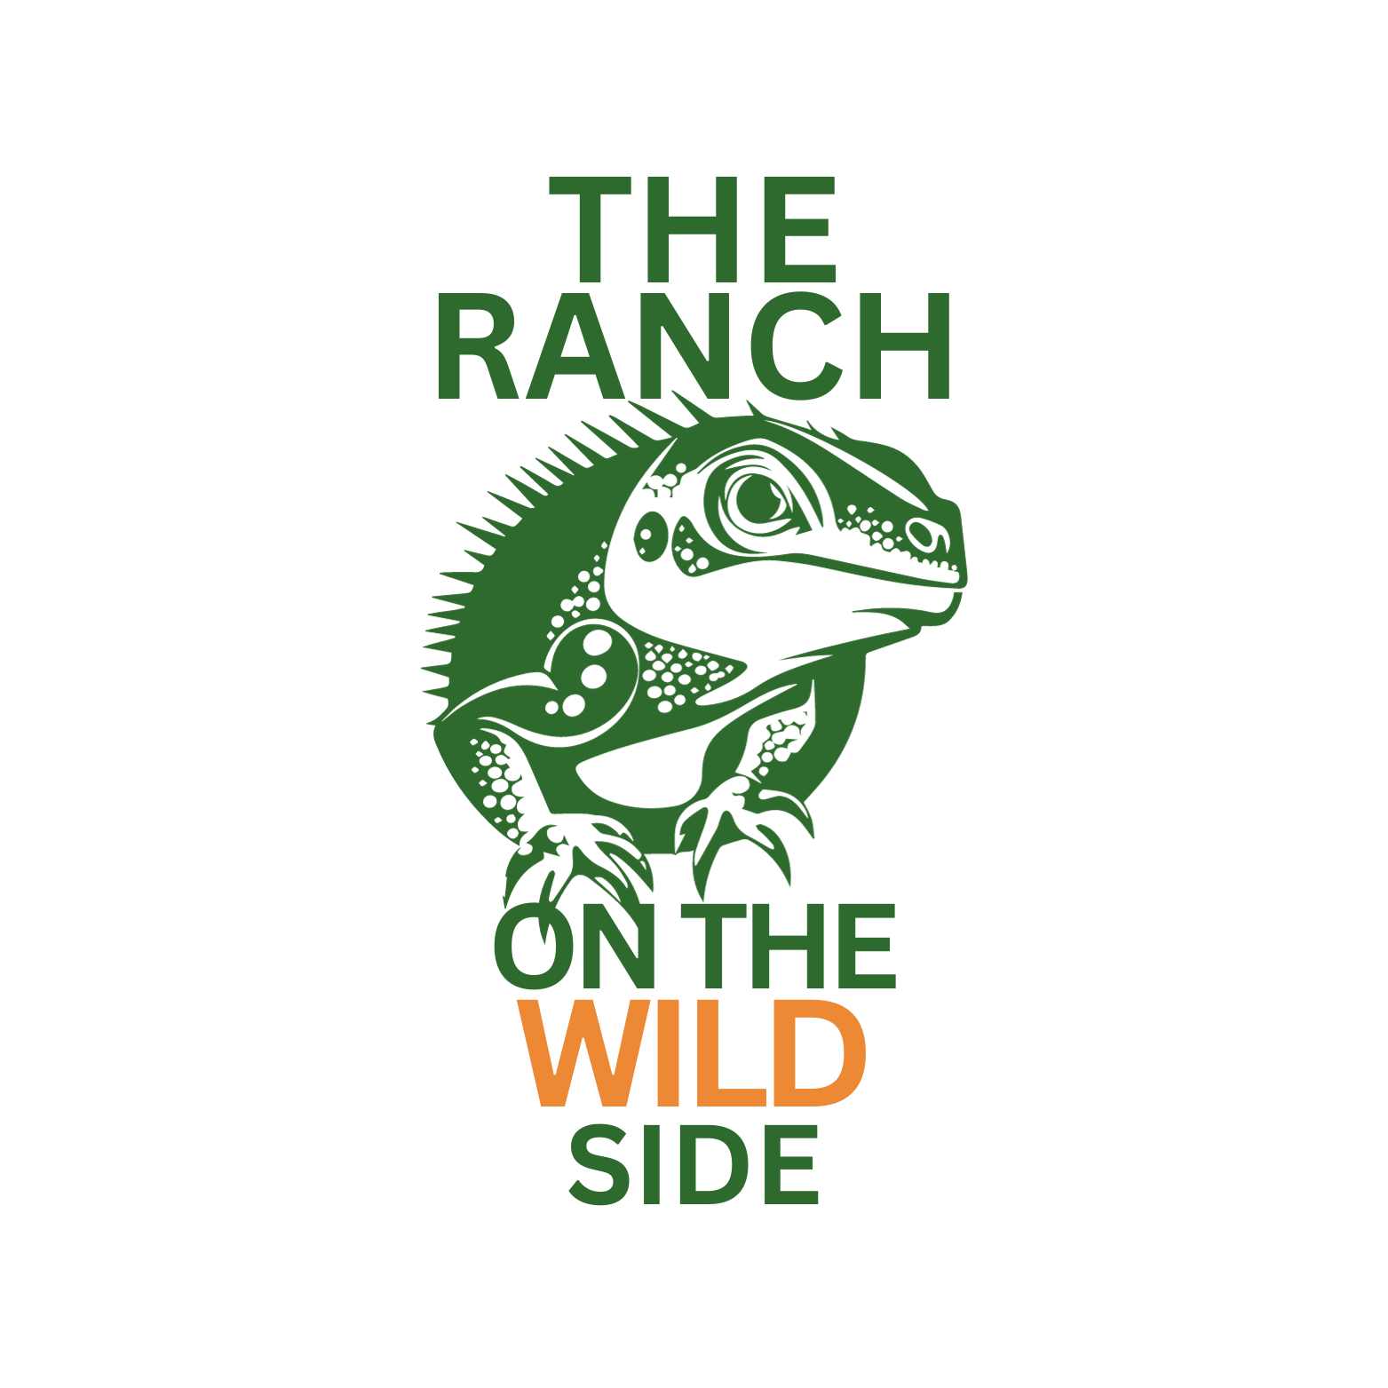
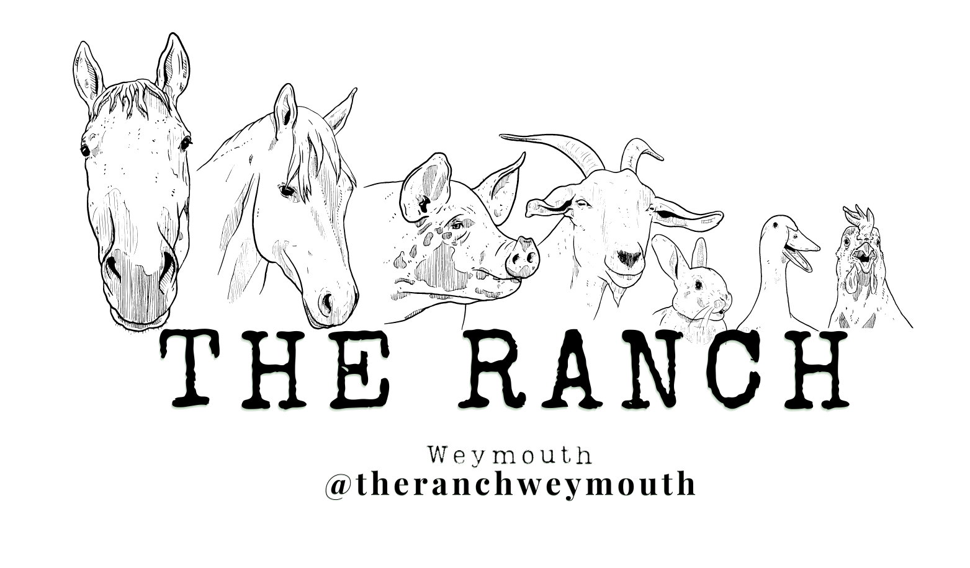
The Ranch Weymouth & The Ranch on the Wild Side

Snake Handling Risk Assessment -
Directorate The Ranch Weymouth CIC
Assessor:
Line Manager/Supervisor:

The animals are well used to human contact by being handled by hundreds of people during many events, festivals, country shows and encounters, which may at times be lasting up to 8hrs per day.
Snakes will be monitored before and during the event (general health, stress, shedding, behaviour, temperament) and could be withdrawn at the discretion of the handlers without notice.
A brief safety talk (5-10 minutes) on handling the animals in the correct and safe manner will occur before handling begins; participants MUST attend the safety briefing before handling.
All participants handle at their own risk and are under no obligation to handle the animals. Participants may be refused from handling the animals at the discretion of the handlers for reasons including but not limited to alcohol consumption or calmness for example
No animals are listed on the Dangerous Wild Animals Act (DWAA) 1976 although we emphasise that any animal with a mouth has the potential to bite.

 | Hazard | Risk | Who might be harmed | Control measures | Probability | Severity | Level of Risk | Comment
1. | Snake bite | Minor Pain  Possible Severe Bleeding Open wound  Bacterial infection | Event attendees  Handlers | - Health and safety briefing and correct snake handling instructions given to participants prior to handling, such as avoid grabbing, touching/poking face and tail areas which are sensitive.  - Animals never left unattended with the public.  - Animals are non-venomous.  - Animals are well fed appropriately before the event.  - Wash hands in alcohol based hand sanitiser before handling to remove scent of food/other animals.  - Behaviour/stress of animals closely monitored and animals removed from handling | Low | Low to Moderate | Low | Seek medical attention from the venue if possible. Contact emergency services if  needed  All incidents are to be reported on as soon as possible.  Any animal can bite, scratch and/or sting. We take the utmost care to prevent any harm coming from encounters. A first aid kit is available within the Reptile House alongside an onsite First Aid trained member of staff.
2. | Constriction (non-bite or after bite) | Asphyxiation  Blood clotting Suffocation | Event attendees Handlers | - Handlers always monitoring snake behaviour for signs of stress.  - Number of people that handle at once is limited to small groups  - Appropriate health & safety handling talk and/or signage to not touch face/tail areas  - Handlers always present to uncoil snake.  - Snake constriction is not very powerful, unlikely to overcome a grown adult human unless unconscious and alone.  - Public asked how they are feeling when handling snakes and if the grip is too tight.  - Grip for snake to hold on is not constriction.  - Handling not allowed for small children i.e. under 3, instead handler to retain hold of snake and allow child to touch. | Low | Low to Moderate | Low | Seek medical attention from venue if possible. Contact emergency services if needed All incidents are to be reported on as soon as possible  Any animal can bite, scratch and/or sting. We take the utmost care to prevent any harm coming from encounters. A first aid kit is available within the Reptile House alongside an onsite First Aid trained member of staff.
3. | Bacterial infection | From bite, touching skin, urine. Commonly associated bacteria include E.coli and Salmonella | Event attendees Handlers | - Wash hands with provided alcohol based hand sanitiser before and after handling to kill bacteria i.e. before eating again.  - Antibiotics should be prescribed by doctor in event of bite.  - Appropriate signage and/or health and safety briefing highlighting risk of bacteria  - Animals are generally bathed after toileting to keep them clean. They are not wild and do not mix with other animals so less likely to contract harmful bacteria.  - Risk of bacteria by handling is no greater than from when you touch an egg or pet dog/cat etc.  - Snakes observed by handlings to watch for signs of toileting (raising of the tail) | Low | Low | Low | All staff and handlers give safety advice before each session to recap the client. On induction new clients will be taken through any risk or hazard and how to approach animals and the importance of hand washing
4. | Allergic reactions to hand sanitiser gel, or in rare case snake skin | Rashes, redness | Event attendees Handlers | - Wet wipes provided, people advised to seek medical attention.  - At least one handler is an emergency first aider. | Low | Low | Low | Activities take place mainly on the site grounds which are designated away from the road and the car park area.  Green hi viz vest are available for use at the office/hide
5. | Snake defecating on somebody during handling | Risk of bacteria and spoiled clothes | Event attendees Handlers | - Monitored for signs of toileting (raising of tail, persistence to reach ground level).  - Snake is given breaks on ground to go to toilet if need be.  - Sanitiser and wet-wipes available | Low to moderate | Low | Low
6. | Injury to the animals | Reptiles catching an infection or getting injury, stress Common infections include RIs (respiratory infections)  Snake may be dropped/grabbed by public | Animals | - Public must sanitise hands before handling to prevent spread of bacteria on them from other animals such as pets to the snakes.  - Snakes must not come into contact with other animals such as dogs which are commonly brought to outdoor events.  - No animals from outside our event can be allowed into the display/handling/photography area.  - Small children must be supported by one of the handlers or a responsible adult.  - Young children must be accompanied by an adult who is responsible for them.  - Snake monitored for stress and may be removed from handling experience with no notice and taken to vet.  - Handlers always present to prevent injury to snake.  - Sometimes people become too excited/erratic and if do not calm down may be asked to leave the handling area | Moderate. | Low | Low to Moderate
7. | Flash photography | Epileptic seizures Other photo-sensitive reactions  Dizziness.  Startling or dazzling | All attendees  Animals | - Appropriate signage of limiting use of flash photography People asked verbally if they are okay with flash photography  - Ask permission to take photographs, ask attendees to turn off flash. | Low | Moderate | Low
8. | Trip hazards | Injuries including banging head, breaks, sprains etc. Such as equipment; cables, Also display table, gazebo and guide ropes | All attendees | - Signs warning about trip hazards and high-vis labelling of guy ropes.  - Cables taped down.  - Restrict access to small numbers at once. | Low | Moderate | Low
9. | Manual handling/lifting related injuries | Such as setting up the gazebo, display and other equipment, lifting boxes,  Holding 20lb snake for a day  Bending down while holding snake for attendees | Handlers | - Work in groups, no lone working. Be aware of people working around you. Take regular breaks.  - Follow correct manual handling procedures. Ask for help if you need it. | Moderate | Moderate | Moderate
10. | Electrical shock Due to photographic equipment such as camera, lighting, power packs | Burns, shocks | Handlers | - Public entering handling area are always supervised by handlers and restricted to small numbers.  - No mains electrical equipment outside handling area.  - Electrical devices out of reach of public.  - Integrity of electrical devices i.e. exposed wires, bent casing etc. checked before events  - Heaters and thermostats checked. | Low | Moderate | Low

The Ranch Weymouth Date ________________________ Assessor __________________________

Directors: Toni Matthews
Iain Woodbridge
James Matthews Woodbridge
Diana Glencross

