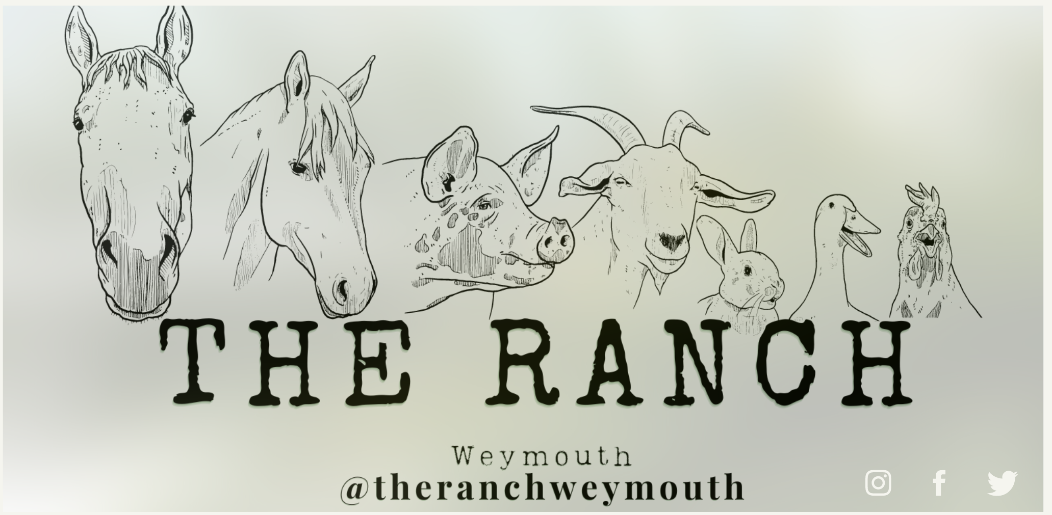

Managing Allegations of Abuse Procedure
Any allegation or concern that a key worker, employee or volunteer has behaved in a way that has harmed or may have harmed a child, must be taken seriously and dealt with promptly. Likewise, allegations against parents/carers, other children and/or other adults, also need to be reported and investigated.
This procedure includes details of:
What happens if The Ranch Weymouth has a safeguarding concern about a child?
What happens if a child discloses that they or another child are being abused?
What happens if an allegation is made against a parent/carer?
What happens if an allegation is made against an employee or volunteer at The Ranch Weymouth? What happens if an allegation is made against a child?
What happens if an allegation is made against a childcare professional from another setting?
How can parents/carers report a safeguarding concern?
What safeguarding information are The Ranch Weymouth in the role of childcare provider required to record and/or report?
What information should parents/ carers inform staff about?
What happens if The Ranch Weymouth has a safeguarding concern about a child?
The Ranch will discuss any concerns with a child’s parent/carer and/or Family Worker/Social Worker if evidence has come to notice of:
• significant changes in a child's behaviour;
• deterioration in a child's general wellbeing and/or appearance;
• unexplained bruising, marks or signs of possible abuse or neglect;
• children’s comments which give cause for concern;
• any reasons to suspect neglect or abuse outside the setting, e.g. family member/friend.
However, if The Ranch believe that it would put the child at risk of further harm or if the concerns relate to potential sexual abuse, The Ranch will report these concerns immediately without questioning the parents/carers. If it were felt that a child was in immediate danger, the police would be contacted immediately.
What happens if a child discloses that they or another child are being abused?
‘Children and young people may disclose abuse in a variety of ways, including: » directly– making specific verbal statements about what’s happened to them; » indirectly – making ambiguous verbal statements which suggest something is wrong; » behaviourally – displaying behaviour that signals something is wrong (this may or may not be deliberate); » non-verbally – writing letters, drawing pictures or trying to communicate in other ways.’ P6, Working Together to Safeguard Children, 2018 NSPCC website
Children and young people may not always be aware that they are disclosing abuse through their actions and behaviour. Sometimes children and young people make partial disclosures of abuse. This means they give some details about what they have experienced, but not the whole picture. They may withhold some information because they: » are afraid they will get in trouble with or upset their family; » want to deflect blame in case of family difficulties as a result of the disclosure; » feel ashamed and/or guilty; » need to protect themselves from having to relive traumatic events.' NSPCC website
If a child makes a disclosure, The Ranch will:
• show that The Ranch have heard what the child is saying and that we take their allegations seriously;
• find a quiet place for them to talk to without being overheard (if this does not disrupt the flow of their disclosure);
• listen carefully, without rushing them and show that We are interested in what they have to say;
• reassure the child that they can tell The Ranch anything that is worrying them but that We cannot promise to keep it a secret because some things must be passed on in order to keep children safe;
• encourage the child to talk, without prompting them or asking them leading questions. The Ranch will not interrupt while a child is recalling significant events and will not make a child repeat their account. The Ranch may however ask them for specific details to clarify something, if necessary, using open phrases such as ‘Tell me about…’, ‘Explain to me…’ and/or ‘Describe to me…’;
• reassure the child that The Ranch are here to help them stay safe and that We will do our best to do so.
• explain what actions The Ranch must take, in a way that is appropriate to the age and understanding of the child;
• record what The Ranch have been told, as soon as possible, using exact words where possible;
• make a note of the date, time, place, and people who were present during the disclosure.
If there is a concern about the child’s welfare, The Ranch DSL will call the Local Safeguarding Partners’ duty desk for advice and an assessment of the situation.
The Ranch will follow up this phone call at a later date if any further information on the matter, either from the child or a family member is obtained. The Ranch will record the concern and all contact with the Local Safeguarding Partners, along with conversations with children, parents/ carers, and witnesses in a safeguarding log, which will be kept centrally stored on our secure and password protected mainframe for the legally required length of time. This record will be passed on to the child’s next setting when they leave (for example, if transitioning to school/setting). The Ranch will ensure that confidential phone calls are not overheard by anyone else and will not discuss safeguarding matters with anyone other than those necessary in order to report the concerns.
What happens if an allegation is made against a parent/carer?
An allegation or concern does not necessarily mean that parents/carers will be reported to the Local Safeguarding Partners for abuse. Any comments that a child makes or potential signs of abuse that have been noticed will be written down in a child’s safeguarding record. Depending on the individual situation, these may or may not be passed on to the Local Safeguarding Partners at that time. The Ranch may discuss concerns with the Local Safeguarding Partners to obtain advice. It may also be the case that a minor concern does not meet the local threshold for intervention and will be noted but no further action taken at that time.
'Not all disclosures will lead to a formal report of abuse, or a case being made, or a case being taken to court, but all disclosures should be taken seriously.' NSPCC website
It is a DSL’s legal duty to record any potential safeguarding concerns, judging the severity of the individual situation to decide on a course of action. Actions may involve some or all of the following:
• further discussion with the child, asking them to clarify their account (without any leading questions or putting words into their mouth);
• a discussion with parents/carers to ask for their version of events (if safe and appropriate to do so);
• a discussion with the Local Safeguarding Partners team asking for advice;
• passing on the child’s details and safeguarding records to the Local Safeguarding Partners team for them to investigate the matter. If a child’s immediate safety is potentially at risk, the police could also be contacted. This would be in the form of an emergency call to 999 if the situation warranted urgent action to protect a child from serious harm.
'Your local council must protect and promote the welfare of vulnerable children in its area. If you have been accused of abusing your child, your local council might investigate. They will try to offer you the support you need and take every step to keep your child at home. In some cases, they might apply for a court order if they think it would be in your child’s best interests.'
What would happen if an allegation were made against an employee or volunteer at The Ranch Weymouth?
An allegation might be made if it is believed that somebody within the setting has:
• harmed a child;
• put a child at risk of harm;
• neglected to keep a child safe from harm;
• acted in an unprofessional manner that suggests they might pose a risk to children;
• committed a criminal offence that relates to a child.
In order to reduce the likelihood of such as accusations occurring, The Ranch Weymouth have a thorough Safeguarding and Child Protection Policy in place, detailing how We will keep children safe. All staff will have had suitability checks and be approved by a registering agency. In addition, The Ranch will follow Safer Recruitment protocol and provide regular training.
Despite best efforts to protect the children in the setting, allegations might still be made.
If any allegations of abuse are made against a staff member, volunteer, a visitor, a person within our safeguarding management team such as DSL, another child in the setting, The Ranch would:
• write a detailed record of all related incidents, including what was said and by whom, with times and dates;
• ask any witnesses (if applicable) to write a statement detailing the incident they observed and to provide their contact details in case it needs to be followed up by the authorities;
• contact the Local Authority’s LADO (Local Authority Designated Officer) for guidance;
• check the Local Authority’s website for details of where The Ranch could access advice and support, if the allegation were regarding DSL or management;
• notify Ofsted/registering agency, as well as The Ranch public liability insurance provider;
• suspend the employee from providing childcare services until a full investigation into the matter has been completed, if advised to do so.
What happens if an allegation is made against a child?
Sometimes there may be an accusation of ‘child-on-child abuse,’ where a child has been accused of abusing another child. This is also sometimes called 'peer-on-peer abuse'.
Incidents of child-on-child abuse may become a safeguarding concern, if:
• significant harm is caused;
• it involves sexualised behaviour;
• the abuse is repetitive rather than a one-off occurrence;
• it is expected that the abuser is mimicking abuse they themselves have suffered or witnessed;
• there is a significant difference in age/size/ability/power between the abuser and their victim;
• the child who is being abused is particularly vulnerable.
In any such cases, the LSP (Local Safeguarding Partner) should be contacted for advice on how to appropriately support the abuser and the victim(s).
For other less serious incidents involving children behaving inappropriately, the setting’s Positive Behaviour Procedure should be used to help children to adapt their behaviour. For older children, The Ranch might also help to write a Child Behaviour Agreement in conjunction with the child and their parents/carers as part of risk management. This may include a list of behaviours that the child will aim to demonstrate, how parents/carers will support the child at home, how The Ranch Weymouth can help within our setting and details of appropriate rewards and sanctions; for example, mobile phone locker.
Where appropriate, families may also need to be signposted to external agencies who are able to offer support and guidance.
What happens if an allegation is made against a childcare professional from another setting?
The Ranch Weymouth have a legal duty to report unacceptable behaviour, such as:
• abuse;
• inappropriate comments;
• failure to effectively safeguard children;
• excessive one-to-one attention;
• the sharing of images without permission;
• other childcare practices that are unprofessional, harmful or are cause for concern.
Any such concerns will be reported to the Local Authority Designated Officer (LADO).
Including the behaviour of assistants or tutors who may be working with on The Ranch site, other childcare providers and other professionals working with children. This action is called ‘whistleblowing’ and may be necessary when a professional’s behaviour is detrimental to children, has placed a child at risk of harm, caused actual harm to a child or is clearly illegal.
The Ranch Weymouth will follow the whistleblowing procedure below if they suspect that any of the above has taken place: A visual escalation procedure and a whistle blowing guide is displayed at all The Ranch sites. This includes contact numbers for LADO and how to raise a concern.
• identify the bad practice;
• record exactly what was observed;
• establish witnesses wherever possible and ask them for written statements;
• keep copies of all correspondence and relevant information;
• seek support from colleagues, where appropriate;
• report concerns to the Local Safeguarding Partners;
• ask to be informed about the outcome.
In these situations, The Ranch may need to contact the police, social workers, the Care Inspectorate, and any other relevant bodies, to pass on any information we may know.
How can parents/carers report a safeguarding concern?
If a parent/carer is concerned about the welfare of a child and has seen or heard something that they feel needs to be reported, they can discuss it with The Ranch Weymouth Directors and/or DSL, if appropriate, or report it directly themselves.
Allegations against a childcare professional should be made to the Local Authority Designated Officer and allegations of other abuse (for example, within the household/family/friends) should be made to the Local Safeguarding Partners team, the full details of which can be found within the Safeguarding and Child Protection Policy – and displayed at each of The Ranch Weymouth sites.
What safeguarding information is a childcare provider required to record and/or report?
If a report is made about a child, in all instances the following will be recorded:
• the child’s full name, age, and address;
• the date and time of the record;
• factual details of the concern (without personal opinions or judgements), for example injuries, what a child has said, who was present;
• details of any previous concerns;
• any action taken, such as speaking to parents/carers (if it is deemed safe to discuss the matter with them) and details of any explanations given.
Written accounts from any witnesses present during a disclosure or events that have caused a safeguarding concern.
These records should also be signed and dated.
It is not The Ranch Weymouth’s responsibility to attempt to investigate the situation, take photographs of injuries or make any judgements. We must simply record the facts and pass them on to the relevant professionals.
What information should parents/ carers inform staff about?
Parents/carers must notify us of any concerns they have about their child, as well as details of any changes in circumstances at home which may affect the child’s emotional or physical wellbeing.
Any relevant details will be recorded, and a parent/carer may be asked to sign that they have seen these notes. Such information may include (but it not limited to):
• accidents, illnesses, and injuries;
• incidents that have upset the child;
• anything that a child is anxious about;
• changes in their family situation;
• new or unusual behaviours;
• changes in sleeping patterns and/ or excessive tiredness;
• changes in appetite and/or food refusal.
It is important that we know these details so that children can be cared for with sensitivity while any issues are monitored and where necessary, addressed.
If you have any concerns about a child, family, or childcare professional, it should always be reported.
Inaction could potentially allow further abuse and could have profound consequences. Safeguarding is everybody's responsibility. Never assume that someone else will report a concern.

